Unit 3 – Lesson 8. Using SQL Joins – Practice 2
Aim:
What are the differences among the SQL joins? How do we use SQL joins more efficiently?

Objectives: After the lesson, students will be able to:
- Obtain basic understanding of RDBMS data structure and data relations
- Write SQL scripts that uses joins effectively

CLASS PROCEDURE:

Do Now: Here are the different join statements in SQL. What are the differences?

- LEFT JOIN

- RIGHT JOIN

- INNER JOIN

- OUTERJOIN

Class Discussions / Presentations:

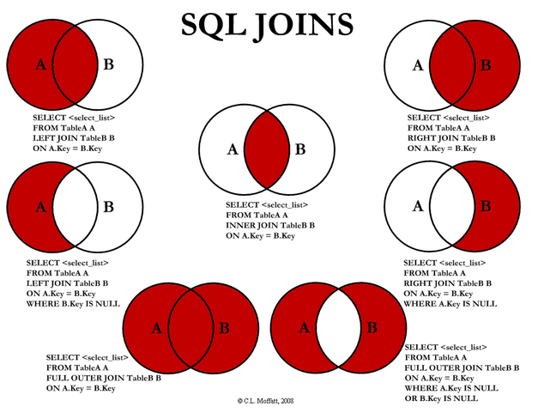

Pair - sharing Activity #1:
Every day, the teachers receive a student absence report for the entire school from the attendance office. Here’s an example:

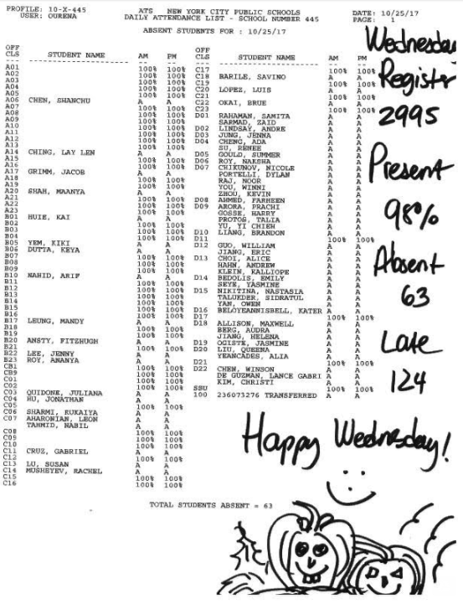
Also, the teacher can download a class roaster from the PupilPath with the students names and OSIS for each class.
- OSIS
- Student Name
- Class Name
- Official Class

How can you design a RDBMS system that takes the table and report given by the attendance office, and automatically create a absent report for each teacher for each day and for each class?

In addition, once in a while, the teachers receive a list of senior students in the entire school who will go on a college trip. Those students shall not be marked as absent. The email normally contains the following data:

- OSIS
- Student Name

How can you NOT mark those students on the college trip absent on the report for each teacher, each class, each day?

Work with your partner to:

- Design database tables to store the data
- Design SQL queries to generate the reports
- Use some dummy data to test your application and make sure it works.

The work will be checked in class tomorrow and graded for 20 points HW credit.

METHOD 1: Student-Oriented
CREATE TABLE teacher(
FIRST_NAME varchar(50),
LAST_NAME varchar(50),
OSIS number(10,0),
CONSTRAINT pk_teacher PRIMARY KEY(OSIS)
)
CREATE TABLE course( TITLE varchar(25), COURSE_ID varchar(5), PERID number(10,0), OSIS number(10,0), CONSTRAINT fk_teacher FOREIGN KEY (OSIS) REFERENCES teacher(OSIS), CONSTRAINT pk_course PRIMARY KEY(COURSE_ID) )
CREATE TABLE student(
FIRST_NAME varchar(50),
LAST_NAME varchar(50),
OSIS number(10,0),
OFCL varchar(5),
GRADE number(4,0),
COURSE_0 varchar(5),
COURSE_1 varchar(5),
COURSE_2 varchar(5),
COURSE_3 varchar(5),
COURSE_4 varchar(5),
COURSE_5 varchar(5),
COURSE_6 varchar(5),
COURSE_7 varchar(5),
COURSE_8 varchar(5),
COURSE_9 varchar(5),
COURSE_10 varchar(5),
CONSTRAINT pk_student PRIMARY KEY (OSIS),
CONSTRAINT course_0 FOREIGN KEY (COURSE_0) REFERENCES course(COURSE_ID),
CONSTRAINT course_1 FOREIGN KEY (COURSE_1) REFERENCES course(COURSE_ID),
CONSTRAINT course_2 FOREIGN KEY (COURSE_2) REFERENCES course(COURSE_ID),
CONSTRAINT course_3 FOREIGN KEY (COURSE_3) REFERENCES course(COURSE_ID),
CONSTRAINT course_4 FOREIGN KEY (COURSE_4) REFERENCES course(COURSE_ID),
CONSTRAINT course_5 FOREIGN KEY (COURSE_5) REFERENCES course(COURSE_ID),
CONSTRAINT course_6 FOREIGN KEY (COURSE_6) REFERENCES course(COURSE_ID),
CONSTRAINT course_7 FOREIGN KEY (COURSE_7) REFERENCES course(COURSE_ID),
CONSTRAINT course_8 FOREIGN KEY (COURSE_8) REFERENCES course(COURSE_ID),
CONSTRAINT course_9 FOREIGN KEY (COURSE_9) REFERENCES course(COURSE_ID),
CONSTRAINT course_10 FOREIGN KEY (COURSE_10) REFERENCES course(COURSE_ID)
)

CREATE TABLE absent( OSIS number(10,0), CONSTRAINT student_absent FOREIGN KEY (OSIS) REFERENCES student(OSIS) )

CREATE TABLE trip( OSIS number(10,0), CONSTRAINT student_trip FOREIGN KEY (OSIS) REFERENCES student(OSIS) )
//non college trip
SELECT FIRST_NAME, LAST_NAME, OSIS, OFCL
FROM student
JOIN trip
ON student.OSIS = trip.OSIS
WHERE TRIP.OSIS IS NULL;

//teacher specific
DECLARE
CURSOR course_rosters IS
SELECT course_id FROM course WHERE OSIS = 1;
course_roster course_rosters%ROWTYPE;
BEGIN
FOR course_roster IN course_rosters LOOP
SELECT FIRST_NAME,LAST_NAME
FROM STUDENT
INNER JOIN TRIP
ON student.OSIS = trip.OSIS
WHERE ( student.course_0 = course_roster.COURSE_ID

OR student.course_1 = course_roster.COURSE_ID

OR student.course_2 = course_roster.COURSE_ID

OR student.course_3 = course_roster.COURSE_ID

OR student.course_4 = course_roster.COURSE_ID

OR student.course_5 = course_roster.COURSE_ID

OR student.course_6 = course_roster.COURSE_ID

OR student.course_7 = course_roster.COURSE_ID

OR student.course_8 = course_roster.COURSE_ID

OR student.course_9 = course_roster.COURSE_ID

OR student.course_10 = course_roster.COURSE_ID)

AND TRIP.OSIS IS NULL;
END LOOP;
END;

//OLD STUFF
CREATE TABLE student(
FIRST_NAME varchar(50),
LAST_NAME varchar(50),
OSIS number(10,0),
OFCL varcahar(5),
GRADE number(4,0),
CONSTRAINT pk_student PRIMARY KEY (OSIS)
)

CREATE TABLE senior_trip(
student_id int FOREIGN KEY REFERENCES students(pk_student)
)

CREATE TABLE teacher(
FIRST_NAME varchar(50),
LAST_NAME varchar(50),
OSIS number(10,0),
CONSTRAINT pk_teacher PRIMARY KEY (OSIS)
)

CREATE TABLE class(
teacher_id FOREIGN KEY REFERENCES teachers(pk_teacher),

)
SELECT FIRST_NAME, LAST_NAME, OSIS, OFCL
FROM student
JOIN senior_trip
ON student.OSIS = senior_trip.OSIS

Pair - sharing Activity #2:
In the Android Example Projects I shared with you a while back with the Cannon game and the Flag Quiz app, there is a project called “Address Book”. Open Android Studio, import the “Address Book” app to Android Studio, and run the project.

Explore the app, add several contacts to the address book.

Explore the source code and discuss with your partner:

- In the java activity programs, where can you find the SQL statements?

- How is SQLite being imported?

- How do we insert a record in SQLite?

- How does program store the records?

- How does the program define the data structure / fields?

